**Hide Subsystem Complexity With Facade**

|  |  |  |
| --- | --- | --- |
| *client code is has become overly complex because of its interaction with various subcomponents* |  | *introduce a Facade to hide subsystem complexity from client code* |

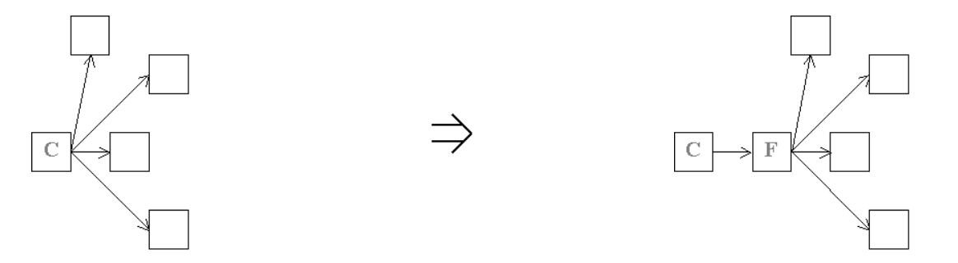

**Context:**  
[Hide Subsystem Complexity With Facade](https://web.archive.org/web/20090914101018/http:/www.refactoring.be/thumbnails/rtn-hscwf.html) is an example of [Introduce Indirection](https://web.archive.org/web/20090914101018/http:/www.refactoring.be/thumbnails/rtn-ii.html) where the indirection level serves to hide the subsystem complexity. Hiding the subsystem by a Facade allows client access to the required behavior in terms of high-level operations.